**Celebrating National Bible Week**

What was National Bible week?

U.S. President Franklin D. Roosevelt commemorated the word of God by observing the first National Bible Week in 1941. Since then, every president has continued the tradition of celebrating the Holy Bible during Thanksgiving week.

Sinking deep into Hitler’s tyranny, the world looked different when FDR helmed the presidency. On December 7, 1941, NBC, the leading radio station at the time, opened the day’s programming with the founders of the National Bible Association. As the program began, the news of the attack on Pearl Harbor broke in the studio. To hold the attention of a shocked and grieving nation, NBC requested the National Bible Association to continue reading the Bible all day. Before the tragedy, the President had invited the founders of the National Bible Association to the White House to lay the foundation for the first National Bible Week. The founders canceled, writing a telegram to the president stating, “May God bless and guide you in this emergency.”

The above information taken from: https:nationaltoday.com/national-bible-week/

See below the telegram from The National Bible Association declined attending FDR’s request to join him in laying the foundation for National Bible Week.

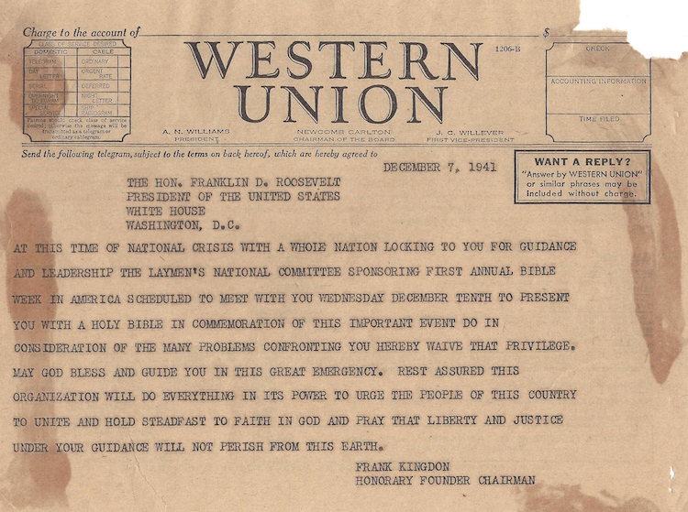

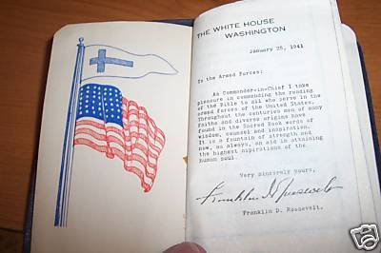

Some folks get upset when they see this Bible as they believe it breaks flag code. FDR was reinstating what the Founding Fathers of America indicated – “God. Country. Family”. Modern history says, “God. Family. Country.” – this is wrong. Our founders understood if God was above our Country, naturally our families would be protected; otherwise, our country would become the enemy of our family.

***“Every member of the State ought diligently to read and to study the constitution of his country, and teach the rising generation to be free. By knowing their rights, they will sooner perceive when they are violated, and be the better prepared to defend and assert them.” John Jay, First Chief Justice of the US Supreme Court***

-how can you share this information?  
-will you celebrate the Bible and live out the freedoms our founders gave us?